IN THE SUPERIOR COURT OF THE VIRGIN ISLANDS
DIVISION OF ST. CROIX

HISHAM HAMED, individually, and derivatively, on behalf of SIXTEEN PLUS CORPORATION,  Plaintiff,  v.  FATHI YUSUF, ISAM YOUSUF and JAMIL YOUSEF  Defendants,  and  SIXTEEN PLUS CORPORATION,  a nominal Defendant. | Case No.: SX-2016-CV-00650  DERIVATIVE SHAREHOLDER SUIT, ACTION FOR DAMAGES AND CICO RELIEF  JURY TRIAL DEMANDED

PLAINTIFF HISHAM HAMED’S
FIRST MOTION TO COMPEL—
AS TO BANK ACCOUNT DOCUMENTS IN THE CONTROL OF ISAM YOUSUF

COMES NOW the plaintiff, Hisham Hamed, through undersigned counsel, and moves the Court, pursuant to Rules 26, 34 and 37, to compel Defendant, Isam Yousuf, to provide his banking records for 1990-1997—or, in the alternative, to provide a letter to opposing counsel allowing counsel to obtain them and bear the expense of doing so,

Mr. Yousuf is an American citizen and the records at issue are his own banking statements concerning two accounts on the island of St. Martin (French) central to this action. In fact, the funds in one of these accounts were used to make the alleged loan at issue here. Isam contends the funds were deposited by his father; Hamed contends they were deposited by the Hameds and Fathi Yusuf. Because Isam repeatedly references these accounts and relies on assertions about these bank accounts in his responsive papers and discovery responses, the account descriptions and statements should have been provided pursuant to his initial Rule 26 disclosure responsibilities. When they were not, they were requested in perhaps the most routine of requests for production. Again, this was a standard, vanilla request for standard, vanilla bank statements of a defendant.

The initial RFPD and subsequent requests were denied in Isam Yousuf’s Responses to RFPD from Attorney Hymes dated August 16, 2017.

Document Request No. 1:

All monthly account statements for any checking, savings, investment, brokerage account titled to you in your name from 1990 through 1997.

Response: None.

Document Request No. 14:

Please provide documents reflecting the source of all funds used to make the wire transfer that was sent on or about February 19 , 1997, as noted on page 6 of Exhibit 4 as well as Exhibit 5 that are attached .

Response: None.

Document Request No. 17:

Please provide documents showing the transfer of any funds by Mana! Mohammad Yousef to you or BFC Island Appliance that were included in either of the wire transfers that were sent on or about February 19, 1997 and September 4, 1997, on noted on page 6 of Exhibit 4 as well as Exhibits 5 and 6 that are attached .

Response: None.

Interrogatory 4:

Please list all financial accounts you have, that are fully or partially in your name1 in any corporation1 partnership or business association in which you own more than 5% interest, or as to which you are a beneficiary from January 11 1995 through December 31 , 2000, including but not be limited to all: bank accounts, stock brokerage accounts, negotiable instrument accounts, retirement accounts, trading or options accounts, and funds transfer accounts. For each, identify the name and address of the institution, the title holder(s), the beneficiaries or trust beneficiaries as well as the last four digits of the account number(s),

Response: BFC Bank - I had a personal bank account. Island Appliances had a business account at the same bank. Windward Island Bank - Island Appliances had a business account with the bank at its Phillipsburg St. Maarten branch. Windward Island Bank - Dyson Island Furniture had a business account at the bank's Phillipsburg St. Maarten branch.

The last response is particularly uninformative. Other documents provided to Attorney Hymes as part of these negotiations to get the documents show Isam Yousuf had many more accounts which he did not disclose. He had at least two additional accounts at BFC opened in 1995. It is also clear he had a major account in Jordan that transferred millions of dollars and Euros. Therefore, Hamed’s counsel met with Attorney Hymes in a Rule 37 conference to identify bank accounts and obtain the production of bank account documents regarding a very narrow time period. That conference was followed with a confirming letter to Attorney Hymes addressing these issues at pages 3 and 4 of Exhibit 1.

e. Interrog 4: I noted that he did not list all accounts in his name and gave you the reference to several. I also asked for all foreign bank accounts during the period 1995- 2000. I also noted that there was inadequate detail for those already described. You said you would check with your client. Again, I expect an amendment.

and

h. Doc Req 1 (and Doc Req 14):

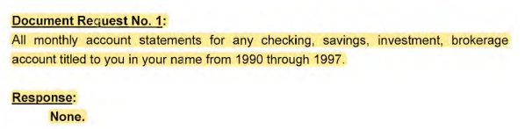

Isam was asked and responded as follows:

You stated that he had none. I stated that he has an obligation to obtain documents within his control, or in the alternative to provide access. Thus, I asked for two letters: (1) to BFC releasing his banking records related to this case, i.e., for the time period 1995-2000, and (2) to the STM prosecutor for records related to the Criminal Procedure numbered—which I had previously described to you in my letter of 10/16/22 as follows: . . . .You said, finally, that you would check with Isam and get back to me as to whether he would assist by supplying access. I noted that it was his duty to obtain records in accounts under his control, not mine, but that if he gave me the letters I would undertake to do so—which I will at our cost.

In addition, Hamed’s counsel then identified missing account numbers he had been able ti locate and provided other salient information in an effort to work out descriptions and access.

On November 7, 2022, Attorney Hymes responded by refusing any disclosure or cooperation. Exhibit 2. Hymes stated: “Access to the financial records of Island Appliances and my clients will not be granted.” In addition he refused to even identify such foreign accounts during held by Isam that period: “You have asked for a description of all foreign bank accounts in his name during the period 1995 2000. Once again, this is irrelevant to any issue related to this case and will not be provided.”

- Introduction

The central factual issue in this series of cases is starkly black and white: Did Manal Yousuf’s father deposit $4.5 million into Isam Yousuf’s Banque Francaise Commerciale (“BFC”) account over a lengthy period, or was the money in that account simply skimmed funds put there over a very short time by Fathi Yusuf, Wally Hamed and Isam Yousuf? In other words, were Manal’s funds loaned to Sixteen Plus to buy the subject land? Or was it Hamed/Yusuf’s funds being deposited and transferred to Sixteen Plus to buy the land? If these were not Manal’s funds, there was “fraud, coercion or other nefarious inducement into the [mortgage] contract.” Celestin v. LLP Mortg., Ltd., No. 2007-014, 2007 V.I. Supreme LEXIS 6, at *5 (Nov. 9, 2007).

Hamed contends that the funds transmitted from by Isam Yousuf were laundered monies belonging solely to Mohammad Hamed and Fathi Yusuf—Isam Yousuf states that they were funds his father deposited over a long period as a gift to Manal Yousuf. This would be simple to discern if these records had been produced. The accounts will show no funds in 1995-1996, and then sudden deposits in large amounts indicative of laundering—and matching the other three accounts on St. Martin used by Isam in an identical manner.

There are known facts about the account in question that strongly infer that these funds were skimmed in the USVI, moved to St. Martin and added in just a few months (June 1996 to January 1997) before transfer by Isam Yousuf to the Sixteen Plus account at ScotiaBank:
- As shown below in great detail, the French Banking Commission and police were able to track “10 consecutive deposits” into the subject account totaling $1.5 million just days before the $2 million transfer at issue—deposits made by Isam to himself in cash.
- Isam already had personal and business accounts at BFC going back to the late 80’s – the target accounts were created specially in 1995 (at the same time the Wally Hamed, Fathi Yusuf and Hamden Diamond accounts were created for money laundering.)
- On one day, more than $8 million flowed into an out of one of these accounts. Exhibit 4.

Thus, Hamed believes that the account statements and documents will show these facts:
- There was little or no money in the subject account before the skimming deposits started in June 1996. Thus, there are no historical deposits from Manal’s father.
- The deposits from June to January were large and quick, and were in the identical pattern as to the other laundering accounts Isam oversaw.
- The amounts used for the transfer to Sixteen Plus were deposited immediately before the transfer, by Isam, in large chunks of cash—not by his father, and not over many years.

- Applicable Rules - V.I. R. CIV. P. 26(a)(1)(iii) and 37(a)(1)

RULE 26

(a) Required Disclosures.

(1) Initial Disclosure.

(A) In General. Except as exempted by Rule 26(a)(1)(B) or as otherwise stipulated or ordered by the court, a party must, without awaiting a discovery request, provide to the other parties:

(i) the name and, if known, the address and telephone number of each individual likely to have discoverable information — along with the subjects of that information — that the disclosing party may use to support its claims or defenses, unless the use would be solely for impeachment.

(ii) a copy of all documents, electronically stored information, and tangible things that the disclosing party has in its possession, custody, or control and may use to support its claims or defenses, unless the use would be solely for impeachment, unless it would be unduly burdensome to produce a copy of an item, in which case each item must be clearly identified, along with a statement as to why each cannot readily be copied, and including a description of the location where each can be reviewed. (Emphasis added.)

Rule 34

Producing Documents, Electronically Stored Information, and Tangible Things, or Entering onto Land, for Inspection and Other Purposes

(a) In General. A party may serve on any other party a request within the scope of Rule 26(b):

(1) to produce and permit the requesting party or its representative to inspect, copy, test, or sample the following items in the responding party's possession, custody, or control: (Emphasis added.)

- Isam’s Control: All Documents…that the…Party has in his…”control”
- Facts

A great deal is known about these two accounts—from official, contemporary documents—governmental, regulatory and police investigations into their use for money laundering. As discussed below, the parties have received, from the U.S. FBI and DOJ, documents which show:
- After 9/11, the U.S. Government asked the French Government for documents regarding the movement of large amounts to the Middle East.
- French Banking Commission Investigated and issued Report on Money Laundering which included these accounts.
- St, Martin Judicial Police were informed, and as a result, opened a criminal investigation.
- As part of their investigation St, Martin Judicial Police issued a subpoena to BFC for these specific accounts, and
- BFC provided copies of all statements and documents on these accounts,

On January 23, 2002, Mary Ellen Warlow, Director, Office of International Affairs, U.S. Department of Justice, sent the French government a request for assistance in connection with an investigation conducted into Fathi, Isam, Wally, Island Appliances and Hamdan Diamond. Exhibit 5. They were conducting an investigation to determine “whether Fathi YUSUF and his accomplices” were trafficking U.S. currency, [and] laundering profits….” Id. Those individuals and companies “had opened several bank accounts with the Saint Martin branch of the Banque Francaise Commerciale.” The American authorities asked for many documents. Id. The St. Martin police opened an investigation and looked at the two Island Appliance Accounts carefully. Id.

Information and documents from that investigation were provided to the French Banking Commission which issued a January 11, 2002 draft report (the parties have the final of this report in French—which contains the same text.)

After the police issued a subpoena (“Requisition”) to BFC for these accounts, the bank sent the following letter confirming that the Isam Yousuf (trade named Island Appliances) account statements and accounting documents had been collected, copied and transmitted. It states, ‘In response to your request of March 13 and at our first delivery on May 02 we send you copies of the documents collected on the following files: YOUSUF ISSA-ISLAND APPLIANCE : accounts n° 60.63541 & 60.20186 Account statements, accounting documents.”
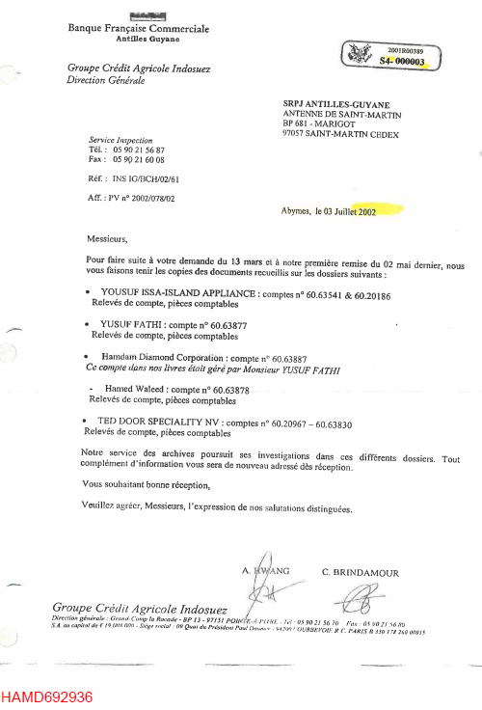
In reporting on the matter, the police lieutenant investigating stated, Exhibit 5: “Our Investigations and hearings allowed us to determine that: 1/ WITH RESPECT TO THE BANK ACCOUNTS OPENED: The different bank requisitions [subpoenas] sent to the Saint Martin Branch of Banque Francaise Commerciale (BFC) allowed us to determine:
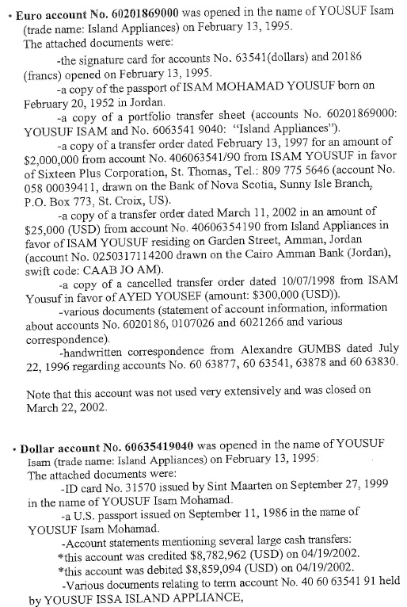
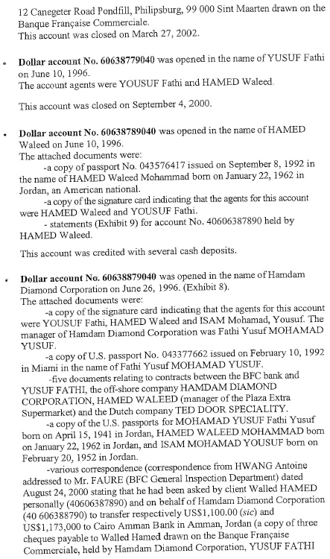
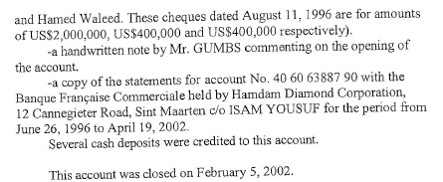

Hamed also contends that when Fathi Yusuf received these reports on the French activities that had been translated into English, he drew up a 4-page, handwritten analysis keyed to those reports individually. He then attached several documents of the French analysis to his handwritten notes (with each French document labeled A through E) and presented them all to Wally Hamed as (1) being an accurate accounting of what they had done, and (2) demanding that the French reprts somehow showed that the Hamed had received more than the Yusufs over the years—and thus, the Hameds owed him money. (This is a very lengthy exhibit, but will be supplied to the Court if this is contested.)
- The Law of “Control”

The legal predicated for such a document request are met. It has been shown that the subject documents existed as described, that they were collected pursuant to a lawful subpoena, and that a set of the copies was transmitted by a bank to the police and prosecutor. Thus, three entities may have a set. Thus, the only question remaining is whether these documents are in Isam’s control. The caselaw on this is uniform. See, e.g. Shorter v. Baca, No. CV 12-7337-JVS (AGR), 2013 U.S. Dist. LEXIS 199847, at *7-8 (C.D. Cal. Nov. 1, 2013)

Shorter objects that at least some documents are not within her possession but are in the possession of St. Francis Medical Center, LA-USC County Medical Center, Centinela Hospital or Cedars Sinai Medical Center. Rule 34 allows a party to request documents that are "in the responding party's possession, custody, or control." Fed. R. Civ. P. 34(a)(1). "Control is defined as the legal right to obtain documents upon demand." United States v. Int'l Union of Petroleum and Indus. Workers, 870 F.2d 1450, 1452 (9th Cir. 1989); Hill v. Eddie Bauer, 242 F.R.D. 556, 560 (C.D. Cal. 2007). Shorter does not deny that she has the legal right to obtain her medical records from her providers upon demand. Shorter must obtain the responsive documents from her health providers or provide Defendants' counsel with written consent to disclosure of her medical records to Defendants by her health providers in the form required by Defendants and her health care providers. (Emphasis supplied.)

This is black letter law. See Holczer v. A.O. Smith Corp. (In re Asbestos Prods. Liab. Litig.), No. 875, 2021 U.S. Dist. LEXIS 202879, at *20-21 (E.D. Pa. Oct. 21, 2021) ("Documents are deemed to be within the party's 'possession, custody or control' if the party has actual possession, custody or control, or has the legal right to obtain the documents on demand. . . . Specifically, control is defined as 'the legal right, authority, or ability to obtain upon demand documents in the possession of another.'" Dixon v. Williams, 2016 U.S. Dist. LEXIS 18829, 2016 WL 631356, at *3 (M.D. Pa. Feb 17, 2016) (quoting In re Bankers Trust Co., 61 F.3d 465, 469 (6th Cir. 1995); Florentia Contracting Corp. v. Resolution Trust Corp., No. 92 CV 1188, 1993 U.S. Dist. LEXIS 5275, 1993 WL 127187, at *3 (S.D.N.Y. Apr. 22, 1993)(Emphasis added).

Medical and bank records are the quintessential documents within the control of an individual. They are foremost of all personal records subject to one’s “ability to obtain upon demand documents in the possession of another.” This most frequently arises in a motion to compel where the court invariably orders either the disclosure or, as above, the mandate to “provide Defendants' counsel with written consent to disclosure.” See Hicks v. Bahadori, No. 2:19-cv-05360-MWF (SK), 2020 U.S. Dist. LEXIS 135909, at *3 (C.D. Cal. Mar. 23, 2020).

all documents—including those in Defendants' past and present financial institutions—that reflect the amounts Plaintiff wired to Defendants on or about October 23, 2017, July 20, 2018, and October 3, 2018, and show how those wired amounts were spent (or are currently kept) by Defendants, are both relevant and proportional. Defendants are therefore ordered to produce, to the extent not already done, all such documents in their possession, custody, or control reflecting Defendants' available accounting of the receipt and expenditure of the wired funds. For instance, if the funds were used to place sport bets, Defendants must produce any documents they have reflecting those transactions. (Emphasis added.)

- Conclusion

There is no doubt that the request for these documents was highly relevant, extremely focused and proportional—and that the document lie within the control of Isam Yousuf. Hamed has retained local counsel on St. Martin and will bear the costs of locating, obtaining and duplicating the documents from the bank, the police and the prosecutor. Hamed asks the Court for an order directing Isam Yousuf to provide a letter and to inform the bank, prosecutor and police of the necessity for these documents before this Court. A proposed order is attached.

Dated: November 8, 2022 A
Carl J. Hartmann III, Esq.
Co-Counsel for Defendants
2940 Brookwind Dr,
Holland, MI 49424
Telephone: (340) 642-4422
Email: carl@carlhartmann.com

Joel H. Holt, Esq.
Counsel for Plaintiffs
Law Offices of Joel H. Holt

CERTIFICATE OF SERVICE

I hereby certify that this document complies with the page or word limitation set forth in Rule 6-1(e) and that on this 8th day of November, 2022, I served a copy of the foregoing by email, via the Court’s E-Filing process, on:

Charlotte Perrell, Esq.

Stefan Herpel, Esq.

Law House, 10000 Frederiksberg Gade
P.O. Box 756
St. Thomas, VI 00804-0756
Tel: (340) 774-4422
sherpel@dtflaw.com

James L. Hymes, III, Esq.
P.O. Box 990
St. Thomas, VI 00804-0990
Tel: (340) 776-3470
jim@hymeslawvi.com

Kevin A. Rames, Esq.
2111 Company Street, Suite 3
Christiansted, VI 00820
Tel: (340) 773-7284
kevin.rames@rameslaw.com
A

CERTIFICATE OF COMPLIANCE WITH RULE 37(a)(1)

I hereby certify that I made the required efforts in good faith to confer with counsel for United and Yusuf in order to obtain the foregoing requested information.

Dated: November 8, 2022 A
IN THE SUPERIOR COURT OF THE VIRGIN ISLANDS
DIVISION OF ST. CROIX

HISHAM HAMED, individually, and derivatively, on behalf of SIXTEEN PLUS CORPORATION,  Plaintiff,  v.  FATHI YUSUF, ISAM YOUSUF and JAMIL YOUSEF  Defendants,  and  SIXTEEN PLUS CORPORATION,  a nominal Defendant. | Case No.: 2016-SX-CV-650  DERIVATIVE SHAREHOLDER SUIT, ACTION FOR DAMAGES AND CICO RELIEF  JURY TRIAL DEMANDED

ORDER

THIS MATTER having come before the Court on the motion of plaintiff pursuant to Rules 37 and 26, and the Court being informed in its premises, it is hereby:

ORDERED, that Isam Yousuf will provide a letter addressed to the St. Martin police authority, the St. Martin prosecutor’s office and to the Banque Francaise Commerciale that will state his permission for Attorneys Holt and Hartmann to view and copy all records of the accounts of Isam Yousuf and Island Appliances for the period from 1990 through the end of 1997 and will attach this order thereto. Hamed will bear the cost of such collection and duplication.

Dated: ________________, 2022

ATTEST: TAMARA CHARLES, _________________________

Clerk of the Court Douglas A. Brady

_________________________ Judge of the Superior Court

By: Court Clerk Supervisor

Isam Yousuf has stated that he was the shareholder and manager of a small furniture and appliance seller on Sint Maarten (Dutch). He appears to be a sole proprietor. He has not alleged or provided documentation that it was a true corporation—and he has refused to provide information about ownership or structure in the same November 7, 2022 Hymes letter discussed herein. Exhibit 2. As will be shown below, these were not entity accounts. They were opened by Isam using his own personal information, are titled in his name and merely show “Island Appliances” as a trade name on a personal account.
By January 31, 1997, in preparation for the transfer of $2 million from Isam’s Island Appliance account, in just that one month he had “deposited, in 10 consecutive transfers” $1.5 million in cash. This fact was later described by the French Banking Commission in its official report—which stated that this should have set off alarms about money laundering and that BFC had failed to properly report this: “At this point, at least a monitoring file should have been set up.” Exhibit 3
As will be discussed below, the pivotal account from which the money was sent to Sixteen Plus would see many millions of dollars pass through, bound for both the USVI and the Middle East. For example, according to the French Police who subpoenaed the BFC account records, on one day, this account was credited $8,782,962 and was then debited $8,859,094 later in the very same day. Exhibit 4

